Certificate of Open Science Teaching Skills
This is to certify that
Simone Pröbstl
has delivered an official workshop on Open Science at Ludwig-Maximilians-Universität München and has demonstrated the knowledge and competencies required to serve as an
Open Science Instructor
26. March 2026
LMU Open Science Center, Ludwig-Maximilians University, Munich

Dr. Sarah von Grebmer zu Wolfsthurn,
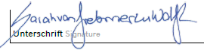
LMU Open Science Center coordinator

